Exercise1:

1.Make your script print another line

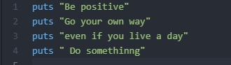

Output:



2.Make your script only one of these lines

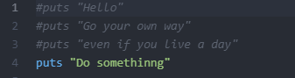

Output:



3.Put a #(octothorpe) character at the beginning of a line. What did it do? Try to find out what this character does.

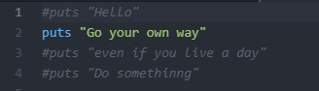

Output:

